**Project_UAS**

**Sistem Checklist Kebersihan Toilet**

|  |  |
| --- | --- |
| Username | admin |
| Password | 1234 |
| Link Web Hosting Demo | https://zamband.000webhostapp.com/ |
| Link YouTube |  |
| Link Github Repository | https://github.com/Febriyaninurhida123/Project_UAS |

**Database Checklist Kebersihan Toilet**

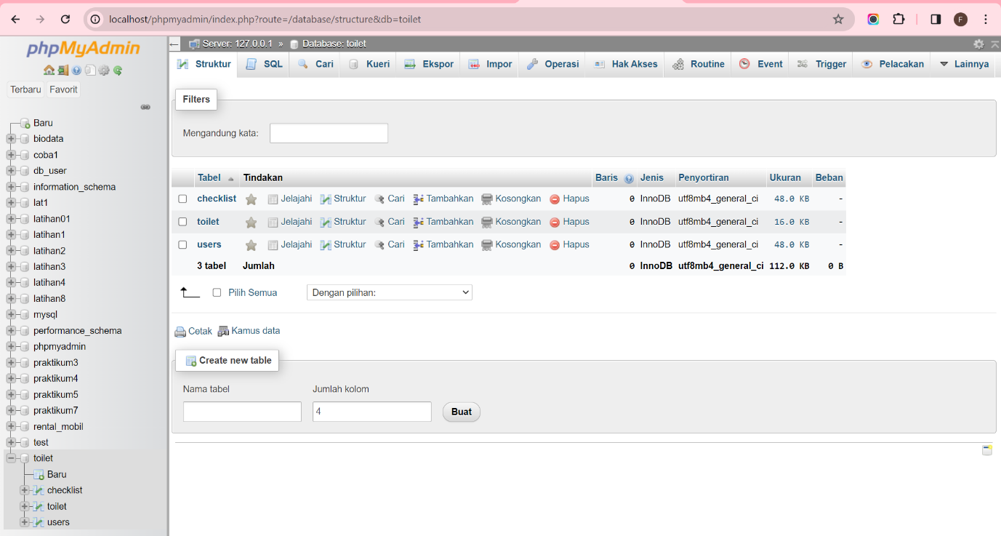

**SQL Checklist: users**

```

CREATE TABLE IF NOT EXISTS `db_checklist`.`users` (

`id` INT NOT NULL AUTO_INCREMENT,

`username` VARCHAR(100) NULL,

`password` VARCHAR(100) NULL,

`nama` VARCHAR(200) NULL,

`email` VARCHAR(200) NULL,

`status` TINYINT(1) NULL,

`role` TINYINT(1) NULL DEFAULT 2 COMMENT '1:Admin\n2:User',

PRIMARY KEY (`id`),

UNIQUE INDEX `username_UNIQUE` (`username` ASC),

UNIQUE INDEX `email_UNIQUE` (`email` ASC))

ENGINE = InnoDB

```

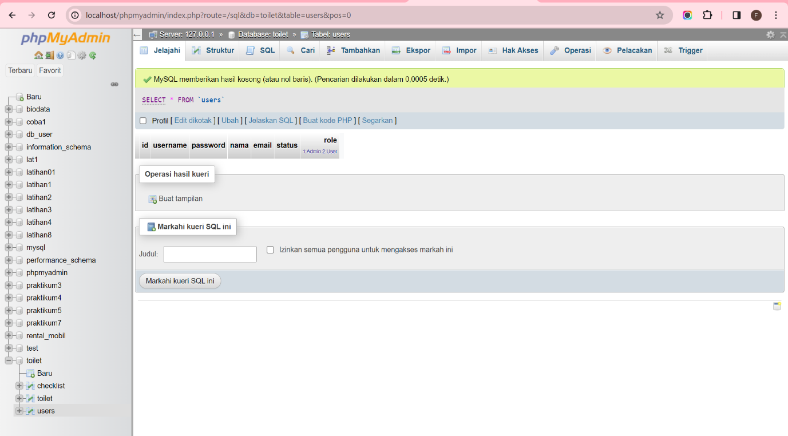

**SQL Checklist: toilet**

```

CREATE TABLE IF NOT EXISTS `mydb`.`toilet` (

`id` INT NOT NULL AUTO_INCREMENT,

`lokasi` VARCHAR(45) NULL,

`keterangan` VARCHAR(45) NULL,

PRIMARY KEY (`id`))

ENGINE = InnoDB

```

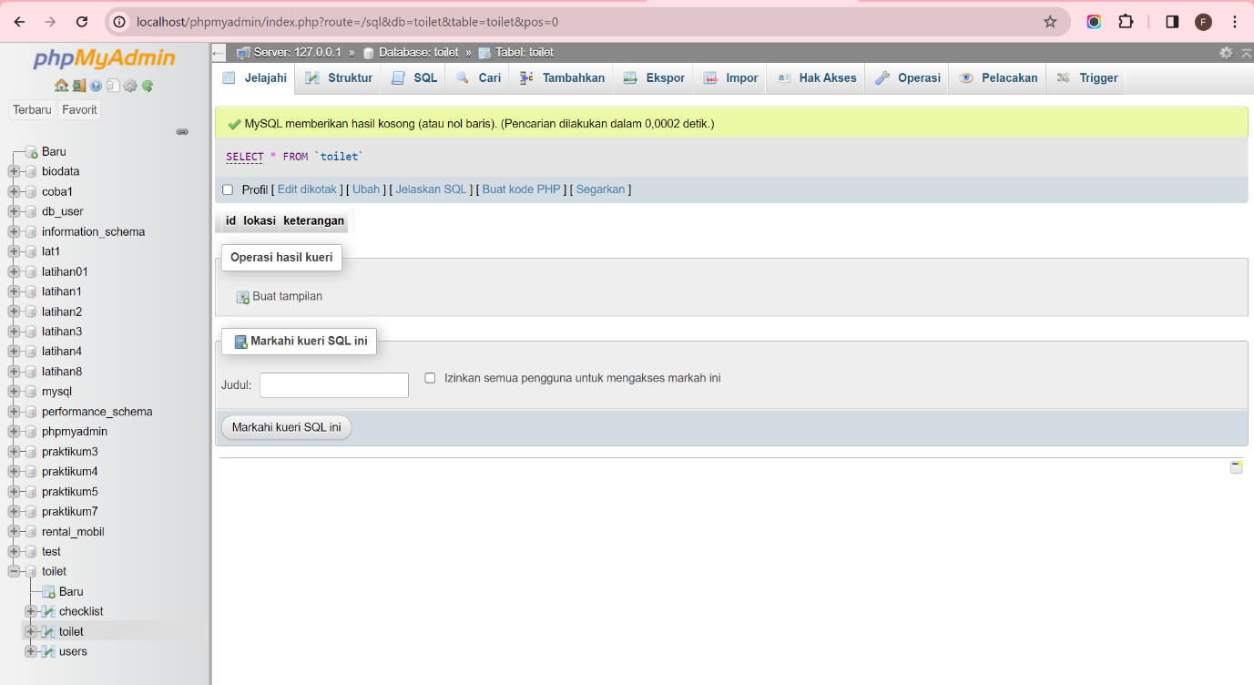

**SQL Checklist: checklist**

```

CREATE TABLE IF NOT EXISTS `mydb`.`checklist` (

`id` INT NOT NULL AUTO_INCREMENT,

`tanggal` DATETIME NULL,

`toilet_id` INT NOT NULL,

`kloset` TINYINT(1) NULL,

`wastafel` TINYINT(1) NULL,

`lantai` TINYINT(1) NULL,

`dinding` TINYINT(1) NULL,

`kaca` TINYINT(1) NULL,

`bau` TINYINT(1) NULL,

`sabun` TINYINT(1) NULL,

`users_id` INT NOT NULL,

PRIMARY KEY (`id`),

INDEX `fk_checklist_toilet_idx` (`toilet_id` ASC),

INDEX `fk_checklist_users1_idx` (`users_id` ASC),

CONSTRAINT `fk_checklist_toilet`

FOREIGN KEY (`toilet_id`)

REFERENCES `mydb`.`toilet` (`id`)

ON DELETE NO ACTION

ON UPDATE NO ACTION,

CONSTRAINT `fk_checklist_users1`

FOREIGN KEY (`users_id`)

REFERENCES `mydb`.`users` (`id`)

ON DELETE NO ACTION

ON UPDATE NO ACTION)

ENGINE = InnoDB

```

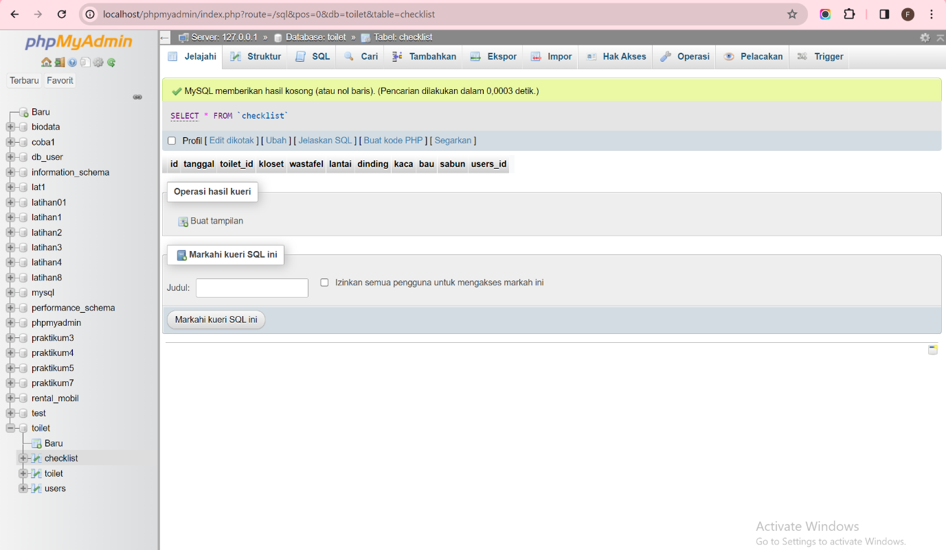

**Membuat file Koneksi.php**

```

<?php

$host = "localhost";

$user = "root";

$pass = "";

$db = "toilet";

$conn = mysqli_connect($host, $user, $pass, $db);

if (!$conn) {

    die("Connection failed: " . mysqli_connect_error());

}

?>

```

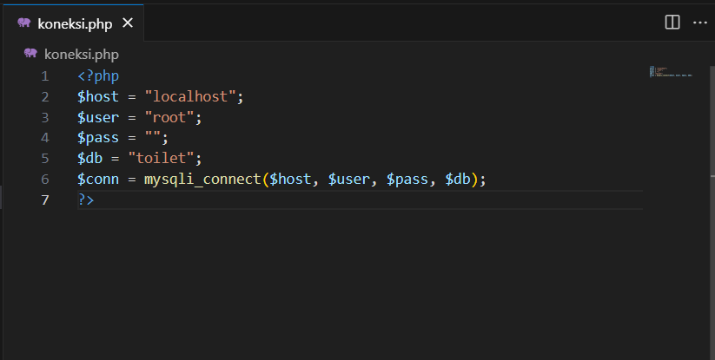

**Membuat file Login.php**

```

<?php

session_start();

$title = 'Login';

include_once 'koneksi.php';

if (isset($_POST['submit'])){

    $username = $_POST['username'];

    $password = $_POST['pass']; // Ganti pass menjadi password

    $sql = "SELECT * FROM users WHERE username = '{$username}' AND password = '{$password}'"; // Ganti pass menjadi password

    $result = mysqli_query($conn, $sql);

    if ($result && mysqli_affected_rows($conn) !=0){

        $_SESSION['login'] = true;

        $_SESSION['username'] = mysqli_fetch_array($result);

        header('location: home.php');

    } else {

        $errorMsg = "<p style=\"color:red;\">Gagal Login, silakan ulangi lagi.</p>";

    }

}

if (isset($errorMsg)) echo $errorMsg;

?>

<!DOCTYPE html>

<html lang="en">

<head>

    <meta charset="UTF-8">

    <title>Febriyani Nurhida UAS</title>

    <link href="https://cdn.jsdelivr.net/npm/bootstrap@5.3.0-alpha1/dist/css/bootstrap.min.css" rel="stylesheet" integrity="sha384-GLhlTQ8iRABdZLl6O3oVMWSktQOp6b7In1Zl3/Jr59b6EGGoI1aFkw7cmDA6j6gD" crossorigin="anonymous">

</head>

<body style="margin-top: 30px; background-image: url('toilet.jpg'); background-size: cover;">

<div class="container" style="width: 50%; padding: 20px; background-color: rgba(0, 0, 255, 0.1);">

    <h1 style="color: #FFFFFF; text-align: center;">DATA CHECKLIST KEBERSIHAN TOILET</h1><br>

    <h2 style="color: #FFFFFF; text-align: center;">LOGIN</h2><br>

    <form method="POST">

        <div class="mb-3 row" style="background-color: #87CEEB;">

            <label for="staticEmail" class="col-sm-2 col-form-label" style="color: #FFFFFF;">Username</label>

            <div class="col-sm-10">

                <input style="color: #000000;" type="text" class="form-control" id="staticEmail" placeholder="Username" name="username">

            </div>

        </div>

        <br>

        <div class="mb-3 row " style="background-color: #87CEEB;">

            <label for="inputPassword" class="col-sm-2 col-form-label" style="color: #FFFFFF;">Password</label>

            <div class="col-sm-10">

                <input type="password" class="form-control" id="inputPassword" placeholder="Password" accept="" name="pass">

            </div>

        </div>

        <br>

        <div class="submit">

            <button type="submit" name="submit" class="btn" style="background-color: #87CEEB; color: #FFFFFF;">Login</button>

        </div>

        <div><br><br>

            <p style="color: white;">Belum memiliki akun ?</p>

            <a href="tam_login.php" style="color: white;">Buat Akun Baru</a>

        </div>

    </form>

</div>

</body>

</html>

```

Output :

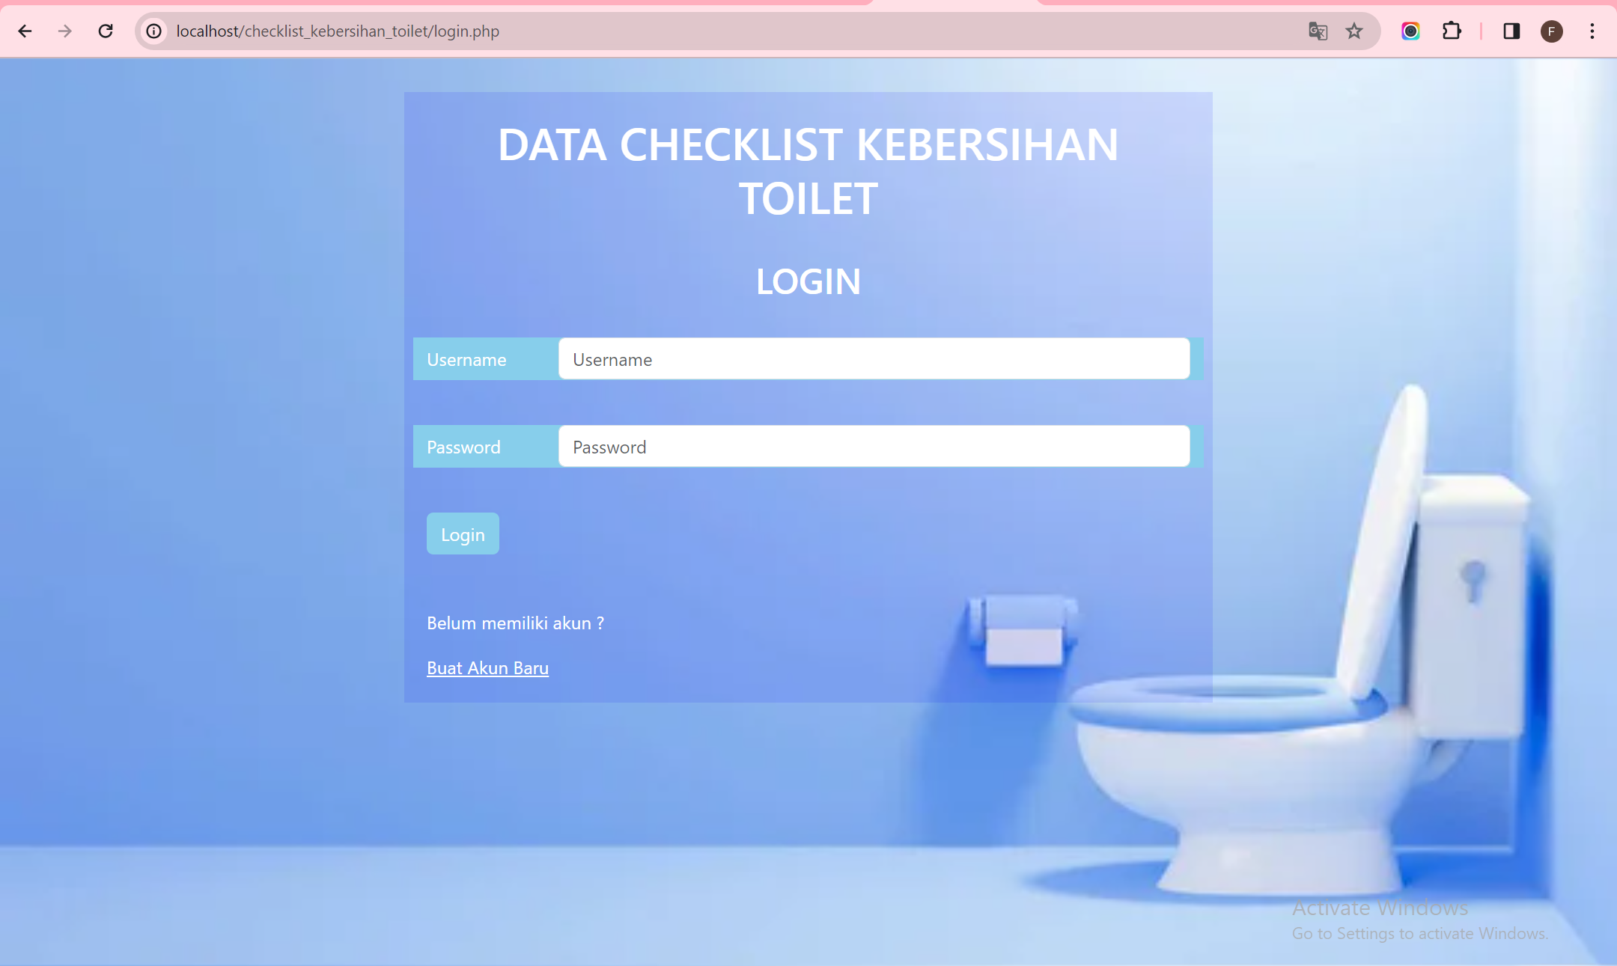

**Membuat file login_session.php**

```

<?php

session_start();

if (!isset($_SESSION['isLogin']))

header('location: login.php');

?>

```

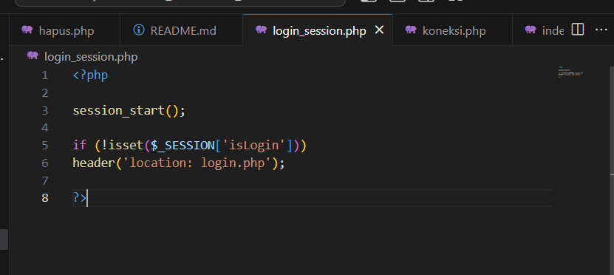

**Membuat file tam_login.php**

```

<?php

error_reporting(E_ALL);

$host = "localhost";

$user = "root";

$pass = "";

$db = "toilet";

$conn = mysqli_connect($host, $user, $pass, $db);

if (!$conn) {

    die("Connection failed: " . mysqli_connect_error());

}

if (isset($_POST['submit'])) {

    $username = mysqli_real_escape_string($conn, $_POST['username']);

    $password = mysqli_real_escape_string($conn, $_POST['pass']);

    $nama = mysqli_real_escape_string($conn, $_POST['nama']);

    $email = mysqli_real_escape_string($conn, $_POST['email']);

    $status = ($_POST['stat'] == 'Aktif') ? 1 : 0; // Convert status to 1 for 'Aktif' and 0 for 'Nonaktif'

    $role = ($_POST['rol'] == 'Admin') ? 1 : 2; // Convert role to 1 for 'Admin' and 2 for 'User'

    $sql = "INSERT INTO users (username, password, nama, email, status, role) VALUES ('$username', '$password', '$nama', '$email', '$status', '$role')";

    $result = mysqli_query($conn, $sql);

    if ($result) {

        echo "Data berhasil disimpan ke dalam database.";

        header('location: index.php'); // Redirect to login.php after successful data insertion

    } else {

        echo "Error: " . mysqli_error($conn);

    }

    mysqli_close($conn);

}

?>

<!DOCTYPE html>

<html lang="en">

<head>

    <meta charset="UTF-8">

    <title>Tambah Akun</title>

    <link href="https://cdn.jsdelivr.net/npm/bootstrap@5.3.0-alpha1/dist/css/bootstrap.min.css" rel="stylesheet" integrity="sha384-GLhlTQ8iRABdZLl6O3oVMWSktQOp6b7In1Zl3/Jr59b6EGGoI1aFkw7cmDA6j6gD" crossorigin="anonymous">

</head>

<body style="margin-top: 30px; background-image: url('toilet.jpg'); background-size: cover;">

<div class="container" style="width: 50%; padding: 20px; background-color: rgba(0, 0, 255, 0.1);">

        <h1 style="color: #FFFFFF; text-align: center;">Tambah Akun</h1>

        <div class="main">

            <form method="post" action="tam_login.php" enctype="multipart/form-data">

                <div class="input-group input-group-sm mb-3">

                <span class="input-group-text" id="inputGroup-sizing-sm">Username</span>

                    <input type="text" name="username" class="form-control" aria-label="Sizing example input" aria-describedby="inputGroup-sizing-sm">

                </div>

                <div class="input-group input-group-sm mb-3">

                <span class="input-group-text" id="inputGroup-sizing-sm">Password</span>

                    <input type="password" name="pass" class="form-control" aria-label="Sizing example input" aria-describedby="inputGroup-sizing-sm">

                </div>

                <div class="input-group input-group-sm mb-3">

                <span class="input-group-text" id="inputGroup-sizing-sm">Nama</span>

                    <input type="text" name="nama" class="form-control" aria-label="Sizing example input" aria-describedby="inputGroup-sizing-sm">

                </div>

                <div class="input-group input-group-sm mb-3">

                <span class="input-group-text" id="inputGroup-sizing-sm">E-mail</span>

                    <input type="text" name="email" class="form-control" aria-label="Sizing example input" aria-describedby="inputGroup-sizing-sm">

                </div>

                <div class="">

                    <h6 style="color: #FFFFFF;">Status</h6>

                    <select class="form-select" aria-label="Default select example" name="stat">

                        <option value=""></option>

                        <option value="Aktif">Aktif</option>

                        <option value="Nonaktif">Non Aktif</option>

                    </select>

                </div><br>

                <div class="">

                    <h6 style="color: #FFFFFF;">Role</h6>

                    <select class="form-select" aria-label="Default select example" name="rol">

                        <option value=""></option>

                        <option value="Admin">Admin</option>

                        <option value="User">User</option>

                    </select>

                </div> <br>

                <input type="submit" name="submit" value="Simpan" class= "btn" style="background-color: #2C74B3; color: #FFFFFF;">

            </form>

        </div>

    </div>

</body>

</html>

```

outputnya :

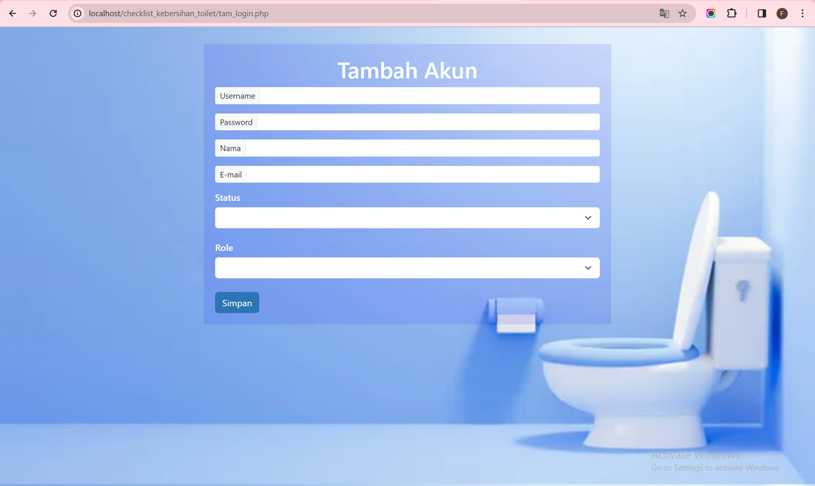**Membuat file Home.php**

```

<?php

session_start();

$title ='Home';

include_once 'koneksi.php';

?>

<!DOCTYPE html>

<html lang="en">

<head>

    <meta charset="UTF-8">

    <title>Febriyani Nurhida</title>

    <link href="style.css" rel="stylesheet" type="text/css" />

    <link href="https://cdn.jsdelivr.net/npm/bootstrap@5.3.0-alpha1/dist/css/bootstrap.min.css" rel="stylesheet" integrity="sha384-GLhlTQ8iRABdZLl6O3oVMWSktQOp6b7In1Zl3/Jr59b6EGGoI1aFkw7cmDA6j6gD" crossorigin="anonymous">

</head>

<body style="margin-top: 30px; background-image: url('bg.jpg'); background-size: cover;">

<h1 style="color: #6699CC; text-align: center; text-shadow: 2px 2px 4px rgba(255, 255, 255, 0.5);">SELAMAT DATANG DI APLIKASI CHECKLIST</h1>

    <div class="container" style="width: 70%; padding: 20px;">

        <ul class="list-group">

            <li class="list-group-item active text-center" aria-current="true" style="background-color: rgba(135, 206, 235, 0.2); font-size: 28px;">Menu</li>

            <li class="list-group-item text-center" style="background-color:rgba(135, 206, 235, 0.2); font-size: 30px;border-color: BLUE"><a style="color: #FFFFFF;" href="toilet.php">Checklist Toilet</a></li>

            <li class="list-group-item text-center" style="background-color:rgba(135, 206, 235, 0.2); font-size: 30px;border-color: BLUE;"><a style="color: #FFFFFF;" href="ind_toilet.php">Data Toilet</a></li>

        </ul>

    </div>

    <div class="d-grid gap-2 container" style="width:10%;">

        <button class="btn" type="button" style="background-color: #89CFF0"><a style="color: #FFFFFF" href="login.php">Logout</a></button>

    </div>

</body>

</html>

```

outputnya :

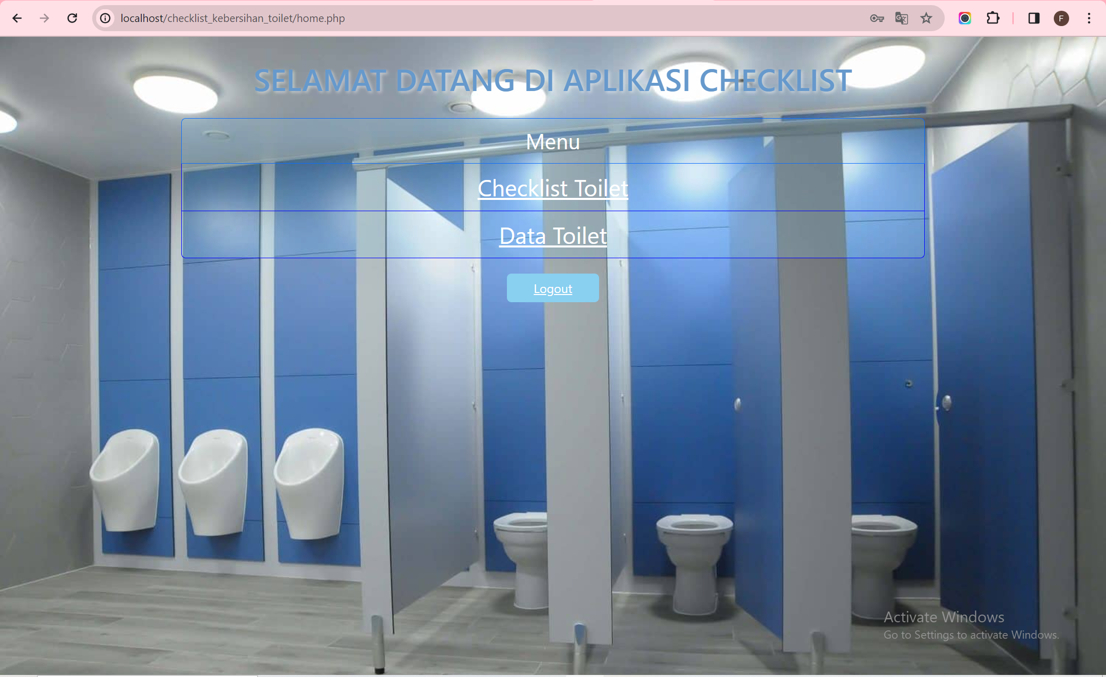

**Membuat file toilet.php**

```

<?php

include("koneksi.php");

$q = "";

if (isset($_GET['submit']) && !empty($_GET['q'])) {

    $q = $_GET['q'];

    $sql_where = "WHERE tanggal LIKE '%".$q."%' or toilet_id LIKE '%".$q."%' or kloset LIKE '%".$q."%' or wastafel LIKE '%".$q."%' or lantai LIKE '%".$q."%' or dinding LIKE '%".$q."%' or sabun LIKE '%".$q."%' or bau LIKE '%".$q."%' or users_id LIKE '%".$q."%'" ;

}

$title = 'Checklist Toilet';

$sql = 'SELECT * FROM checklist ';

if (isset($sql_where))

    $sql .= $sql_where;

$result = mysqli_query($conn, $sql);

?>

<!DOCTYPE html>

<html lang="en">

<head>

    <meta charset="UTF-8">

    <title>Febriyani Nurhida UAS</title>

    <link href="style.css" rel="stylesheet" type="text/css" />

    <link href="https://cdn.jsdelivr.net/npm/bootstrap@5.3.0-alpha1/dist/css/bootstrap.min.css" rel="stylesheet" integrity="sha384-GLhlTQ8iRABdZLl6O3oVMWSktQOp6b7In1Zl3/Jr59b6EGGoI1aFkw7cmDA6j6gD" crossorigin="anonymous">

</head>

<body style="margin-top: 30px; background-image: url('wcc.jpg'); background-size: cover;">

<div class="container" style="width: 70%; padding: 20px; background-color: rgba(143, 145, 144, 0.2);">

        <br><br>

        <div class="head">

        <h1 style="color: #FFFFFF;">Checklist Toilet</h1>

        <form>

            <div class="form-group" action="toilet.php" method="get" >

                <label for="q" style="color: #FFFFFF;">Cari Data Toilet</label>

                <input type="text" placeholder="Masukkan Pencarian"  id="q" name="q" class="input-q" value="<?php echo $q ?>">

                <button type="submit" name="submit" class="btn btn-primary">Cari</button>

            </div>

        </form>

        </div>

        <div class="main">

            <table class="table table-striped table-hover">

            <tr>

                <th style="color: #FFFFFF;">Tanggal</th>

                <th style="color: #FFFFFF; width: 5%;">Kode Toilet</th>

                <th style="color: #FFFFFF;">Kloset</th>

                <th style="color: #FFFFFF;">Wastafel</th>

                <th style="color: #FFFFFF;">Lantai</th>

                <th style="color: #FFFFFF;">Dinding</th>

                <th style="color: #FFFFFF;">Kaca</th>

                <th style="color: #FFFFFF;">Bau</th>

                <th style="color: #FFFFFF;">Sabun</th>

                <th style="color: #FFFFFF;">Petugas</th>

                <th style="color: #FFFFFF; width: 5%;">ID Barang</th>

                <th style="color: #FFFFFF;">Aksi</th>

            </tr>

            <?php if($result): ?>

            <?php while($row = mysqli_fetch_assoc($result)): ?>

            <tr>

                <td style="color: #FFFFFF;"><?= $row['tanggal'];?></td>

                <td style="color: #FFFFFF;"><?= $row['toilet_id'];?></td>

                <td style="color: #FFFFFF;"><?= $row['kloset'];?></td>

                <td style="color: #FFFFFF;"><?= $row['wastafel'];?></td>

                <td style="color: #FFFFFF;"><?= $row['lantai'];?></td>

                <td style="color: #FFFFFF;"><?= $row['dinding'];?></td>

                <td style="color: #FFFFFF;"><?= $row['kaca'];?></td>

                <td style="color: #FFFFFF;"><?= $row['bau'];?></td>

                <td style="color: #FFFFFF;"><?= $row['sabun'];?></td>

                <td style="color: #FFFFFF;"><?= $row['users_id'];?></td>

                <td style="color: #FFFFFF;"><?= $row['id'];?></td>

                <td style="color: #FFFFFF;">

                    <button class="btn" type="button"><a style="color: #FFFFFF;" href="ubah.php?id=<?= $row['id'];?>">Ubah Data</a></button>

                    <button class="btn" type="button"><a style="color: RED;" href="hapus.php?id=<?= $row['id'];?>">Hapus Data</a></button>

                </td>

            </tr>

            <?php endwhile; else: ?>

            <tr>

                <td style="color: #7eeef3;" colspan="7">Belum ada data</td>

            </tr>

            <?php endif; ?>

            </table>

        </div><br><br><br>

        <div>

        <button class="btn" type="button"><a style="color: #FFFFFF" href="tambah.php">Tambah Data Checklist</a></button>

        </div> <br>

        <div>

        <button class="btn" type="button"><a style="color: #FFFFFF" href="home.php">Kembali</a></button>

        </div>

    </div>

</body>

</html>

```

outputnya:

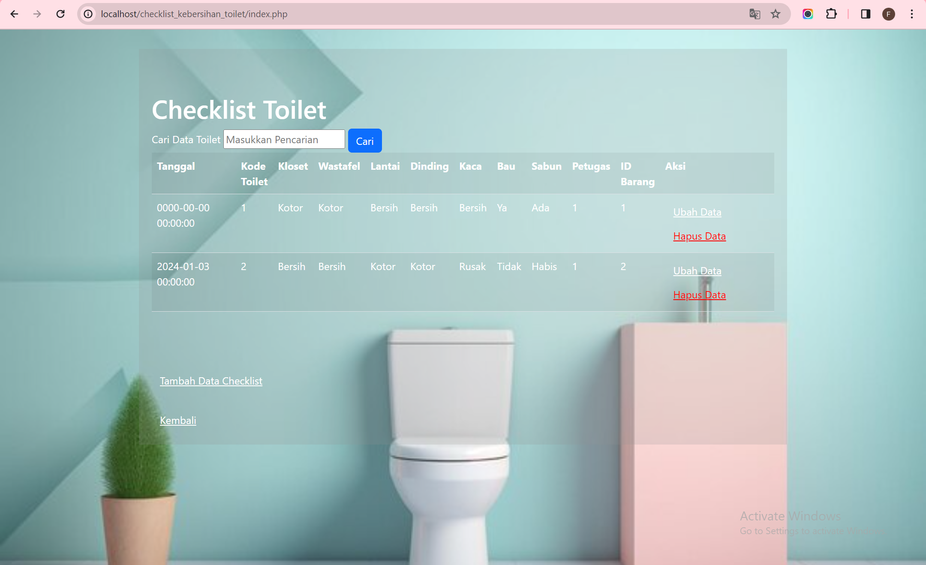

**Membuat file tambah.php**

```

<?php

error_reporting(E_ALL);

include_once 'koneksi.php';

if (isset($_POST['submit']))

{

    $tanggal = $_POST['tanggal'];

    $toilet_id = $_POST['toilet_id'];

    $kloset = $_POST['kloset'];

    $wastafel = $_POST['wastafel'];

    $lantai = $_POST['lantai'];

    $dinding = $_POST['dinding'];

    $kaca = $_POST['kaca'];

    $bau = $_POST['bau'];

    $sabun = $_POST['sabun'];

    $users_id = $_POST['users_id'];

    $sql = 'INSERT INTO checklist (tanggal, toilet_id, kloset, wastafel, lantai, dinding, kaca, bau, sabun, users_id) ';

    $sql .= "VALUES ('{$tanggal}', '{$toilet_id}', '{$kloset}', '{$wastafel}', '{$lantai}', '{$dinding}', '{$kaca}', '{$bau}', '{$sabun}', '{$users_id}')";

    $result = mysqli_query($conn, $sql);

    header('location: toilet.php');

}

?>

<!DOCTYPE html>

<html lang="en">

<head>

    <meta charset="UTF-8">

    <title>Tambah Data</title>

    <link href="https://cdn.jsdelivr.net/npm/bootstrap@5.3.0-alpha1/dist/css/bootstrap.min.css" rel="stylesheet" integrity="sha384-GLhlTQ8iRABdZLl6O3oVMWSktQOp6b7In1Zl3/Jr59b6EGGoI1aFkw7cmDA6j6gD" crossorigin="anonymous">

</head>

<body style="margin-top: 30px; background-image: url('toilet.jpg'); background-size: cover;">

<div class="container" style="width: 50%; padding: 20px; background-color: rgba(0, 0, 255, 0.1);">

        <h1 style="color: #FFFFFF; text-align: center;">Tambah Data</h1>

        <div class="main">

            <form method="post" action="tambah.php" enctype="multipart/form-data">

                <div class="input-group">

                    <span class="input-group-text">Tanggal</span>

                    <input class="form-control" type="date" name="tanggal" data-date-format="DD/MMM/YYYY" placeholder="dd/mm/yyyy">

                </div><br>

                <div class="input-group">

                    <span class="input-group-text">Kode Toilet</span>

                    <input class="form-control" type="text" name="toilet_id">

                </div><br>

                <div class="input-group">

                    <span class="input-group-text">Kode Petugas</span>

                    <input class="form-control" type="text" name="users_id">

                </div>

                <div class="input">

                    <label style="color: #FFFFFF;">Kloset</label>

                    <select class="form-select" aria-label="Default select example" name="kloset">

                        <option value=""></option>

                        <option value="Bersih">Bersih</option>

                        <option value="Kotor">Kotor</option>

                        <option value="Rusak">Rusak</option>

                    </select>

                </div>

                <div class="input">

                    <label style="color: #FFFFFF;">Wastafel</label>

                    <select class="form-select" aria-label="Default select example" name="wastafel">

                        <option value=""></option>

                        <option value="Bersih">Bersih</option>

                        <option value="Kotor">Kotor</option>

                        <option value="Rusak">Rusak</option>

                    </select>

                </div>

                <div class="input">

                    <label style="color: #FFFFFF;">Lantai</label>

                    <select class="form-select" aria-label="Default select example" name="lantai">

                        <option value=""></option>

                        <option value="Bersih">Bersih</option>

                        <option value="Kotor">Kotor</option>

                        <option value="Rusak">Rusak</option>

                    </select>

                </div>

                <div class="input">

                    <label style="color: #FFFFFF;">Dinding</label>

                    <select class="form-select" aria-label="Default select example" name="dinding">

                        <option value=""></option>

                        <option value="Bersih">Bersih</option>

                        <option value="Kotor">Kotor</option>

                        <option value="Rusak">Rusak</option>

                    </select>

                </div>

                <div class="input">

                    <label style="color: #FFFFFF;">Kaca</label>

                    <select class="form-select" aria-label="Default select example" name="kaca">

                        <option value=""></option>

                        <option value="Bersih">Bersih</option>

                        <option value="Kotor">Kotor</option>

                        <option value="Rusak">Rusak</option>

                    </select>

                </div>

                <div class="input">

                    <label style="color: #FFFFFF;">Bau</label>

                    <select class="form-select" aria-label="Default select example" name="bau">

                        <option value=""></option>

                        <option value="Ya">Ya</option>

                        <option value="Tidak">Tidak</option>

                    </select>

                </div>

                <div class="input">

                    <label style="color: #FFFFFF;">Sabun</label>

                    <select class="form-select" aria-label="Default select example" name="sabun">

                        <option value=""></option>

                        <option value="Ada">Ada</option>

                        <option value="Habis">Habis</option>

                        <option value="Hilang">Hilang</option>

                    </select>

                </div><br>

                <input class= "btn" style="background-color: #2C74B3; color: #FFFFFF;" type="submit" name="submit" value="Simpan">

            </form>

        </div>

    </div>

</body>

</html>

```

outpunya :

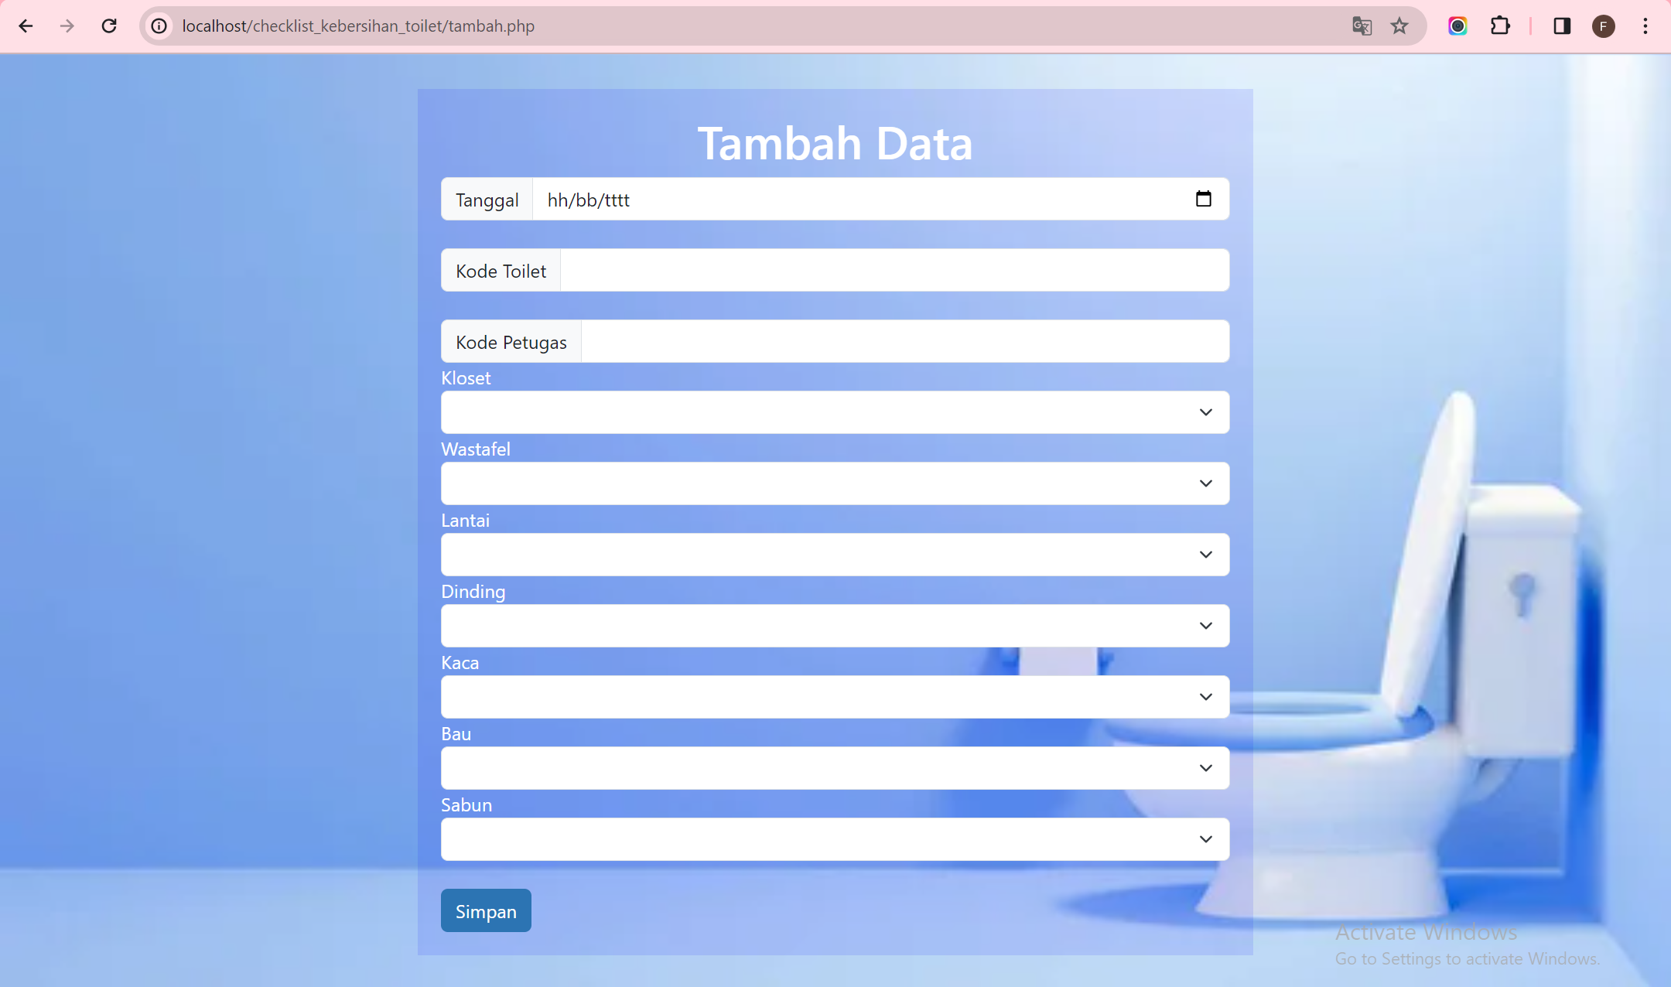**Membuat file ubah.php**

```

<?php

error_reporting(E_ALL);

include_once 'koneksi.php';

if (isset($_POST['submit']))

{

    $id = $_POST['id'];

    $tanggal = $_POST['tanggal'];

    $toilet_id = $_POST['toilet_id'];

    $kloset = $_POST['kloset'];

    $wastafel = $_POST['wastafel'];

    $lantai = $_POST['lantai'];

    $dinding = $_POST['dinding'];

    $kaca = $_POST['kaca'];

    $bau = $_POST['bau'];

    $sabun = $_POST['sabun'];

    $users_id = $_POST['users_id'];

    $sql = "UPDATE checklist SET tanggal = '$tanggal', toilet_id = '$toilet_id', kloset = '$kloset',

    wastafel = '$wastafel', lantai = '$lantai', dinding = '$dinding', kaca = '$kaca',

    bau = '$bau', sabun = '$sabun', users_id = '$users_id' ";

    $sql .= "WHERE id = '{$id}'";

    $result = mysqli_query($conn, $sql);

    header('location: toilet.php');

    }

    $id = $_GET['id'];

    $sql = "SELECT * FROM checklist WHERE id = '{$id}'";

    $result = mysqli_query($conn, $sql);

    if (!$result) die('Error: Data tidak tersedia');

    $data = mysqli_fetch_array($result);

    function is_select($var, $val) {

        if ($var == $val) return 'selected="selected"';

        return false;

}

?>

<!DOCTYPE html>

<html lang="en">

<head>

    <meta charset="UTF-8">

    <title>Ubah Data</title>

    <link href="https://cdn.jsdelivr.net/npm/bootstrap@5.3.0-alpha1/dist/css/bootstrap.min.css" rel="stylesheet" integrity="sha384-GLhlTQ8iRABdZLl6O3oVMWSktQOp6b7In1Zl3/Jr59b6EGGoI1aFkw7cmDA6j6gD" crossorigin="anonymous">

</head>

<body style="margin-top: 30px; background-image: url('toilet.jpg'); background-size: cover;">

<div class="container" style="width: 50%; padding: 20px; background-color: rgba(0, 0, 255, 0.1);">

        <h1 style="color: #FFFFFF; text-align: center;">Ubah Data</h1>

        <div class="main">

            <form method="post" action="ubah.php" enctype="multipart/form-data">

                <div class="input-group">

                    <span class="input-group-text">Tanggal</span>

                    <input class="form-control" type="date" name="tanggal" data-date-format="DD/MMM/YYYY" placeholder="dd/mm/yyyy" value = "<?php echo $data['tanggal'];?>"/>

                </div><br>

                <div class="input-group">

                    <span class="input-group-text">Kode Toilet</span>

                    <input class="form-control" type="text" name="toilet_id" value="<?php echo $data['toilet_id'];?>"/>

                </div><br>

                <div class="input-group">

                    <span class="input-group-text">Kode Petugas</span>

                    <input class="form-control" type="text" name="users_id" value="<?php echo $data['users_id'];?>"/>

                </div><br>

                <div class="input">

                    <label style="color: #FFFFFF;">Kloset</label>

                    <select class="form-select" aria-label="Default select example" name="kloset">

                        <option <?php echo is_select ('Bersih', $data['kloset']);?> value="Bersih">Bersih</option>

                        <option <?php echo is_select ('Kotor', $data['kloset']);?> value="Kotor">Kotor</option>

                        <option <?php echo is_select ('Rusak', $data['kloset']);?> value="Rusak">Rusak</option>

                    </select>

                </div>

                <div class="input">

                    <label style="color: #FFFFFF;">Wastafel</label>

                    <select class="form-select" aria-label="Default select example" name="wastafel">

                        <option <?php echo is_select ('Bersih', $data['wastafel']);?> value="Bersih">Bersih</option>

                        <option <?php echo is_select ('Kotor', $data['wastafel']);?> value="Kotor">Kotor</option>

                        <option <?php echo is_select ('Rusak', $data['wastafel']);?> value="Rusak">Rusak</option>

                    </select>

                </div>

                <div class="input">

                    <label style="color: #FFFFFF;">Lantai</label>

                    <select class="form-select" aria-label="Default select example" name="lantai">

                        <option <?php echo is_select ('Bersih', $data['lantai']);?> value="Bersih">Bersih</option>

                        <option <?php echo is_select ('Kotor', $data['lantai']);?> value="Kotor">Kotor</option>

                        <option <?php echo is_select ('Rusak', $data['lantai']);?> value="Rusak">Rusak</option>

                    </select>

                </div>

                <div class="input">

                    <label style="color: #FFFFFF;">Dinding</label>

                    <select class="form-select" aria-label="Default select example" name="dinding">

                        <option <?php echo is_select ('Bersih', $data['dinding']);?> value="Bersih">Bersih</option>

                        <option <?php echo is_select ('Kotor', $data['dinding']);?> value="Kotor">Kotor</option>

                        <option <?php echo is_select ('Rusak', $data['dinding']);?> value="Rusak">Rusak</option>

                    </select>

                </div>

                <div class="input">

                    <label style="color: #FFFFFF;">Kaca</label>

                    <select class="form-select" aria-label="Default select example" name="kaca">

                        <option <?php echo is_select ('Bersih', $data['kaca']);?> value="Bersih">Bersih</option>

                        <option <?php echo is_select ('Kotor', $data['kaca']);?> value="Kotor">Kotor</option>

                        <option <?php echo is_select ('Rusak', $data['kaca']);?> value="Rusak">Rusak</option>

                    </select>

                </div>

                <div class="input">

                    <label style="color: #FFFFFF;">Bau</label>

                    <select class="form-select" aria-label="Default select example" name="bau">

                        <option <?php echo is_select ('Ya', $data['bau']);?> value="Ya">Ya</option>

                        <option <?php echo is_select ('Tidak', $data['bau']);?> value="Tidak">Tidak</option>

                    </select>

                </div>

                <div class="input">

                    <label style="color: #FFFFFF;">Sabun</label>

                    <select class="form-select" aria-label="Default select example" name="sabun">

                        <option <?php echo is_select ('Ada', $data['sabun']);?> value="Ada">Ada</option>

                        <option <?php echo is_select ('Habis', $data['sabun']);?> value="Habis">Habis</option>

                        <option <?php echo is_select ('Hilang', $data['sabun']);?> value="Hilang">Hilang</option>

                    </select>

                </div>

                <div>

                <input type="hidden" name="id" value="<?php echo $data['id'];?>">

                <input class= "btn" style="background-color: #2C74B3; color: #FFFFFF;" type="submit" name="submit" value="Simpan">

                </div>

            </form>

        </div>

    </div>

</body>

</html>

```

outputnya:

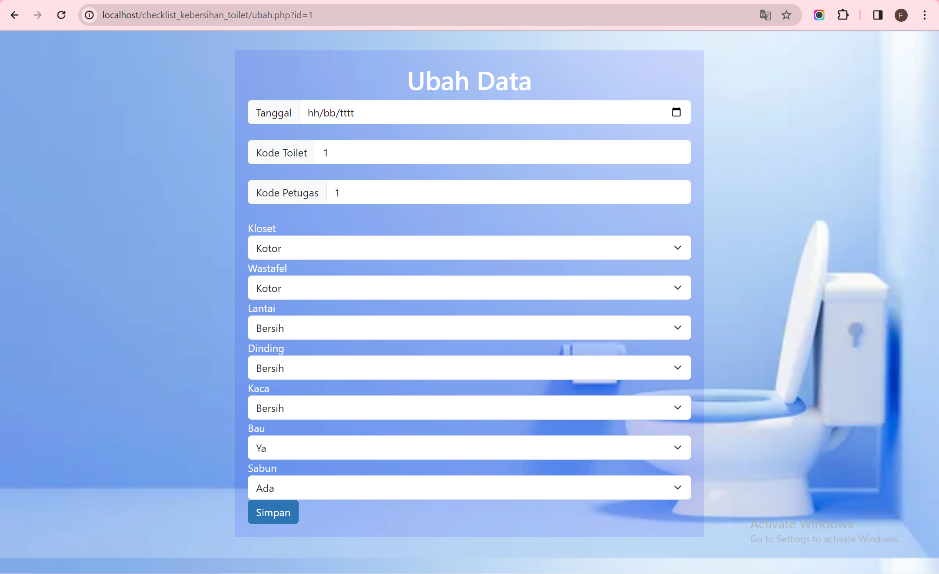

**Membuat file hapus.php**

```

<?php

include_once 'koneksi.php';

$id = $_GET['id'];

$sql = "DELETE FROM checklist WHERE id = '{$id}'";

$result = mysqli_query($conn, $sql);

header('location: toilet.php');

?>

```

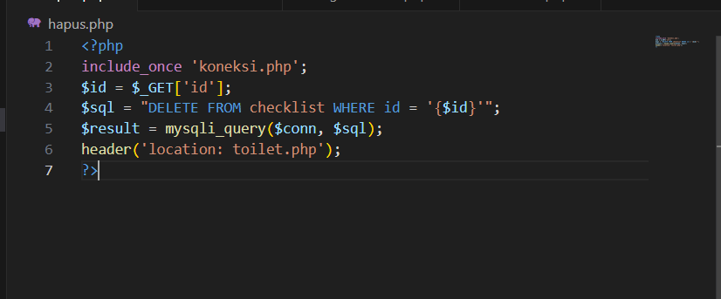

**Membuat file ind_toilet.php**

```

<?php

include("koneksi.php");

$q = "";

if (isset($_GET['submit']) && !empty($_GET['q'])) {

    $q = $_GET['q'];

    $sql_where = "WHERE keterangan LIKE '%".$q."%' or lokasi LIKE '%".$q."%'";

}

$title = 'Toilet';

$sql = 'SELECT * FROM toilet ';

if (isset($sql_where))

    $sql .= $sql_where;

$result = mysqli_query($conn, $sql);

?>

<!DOCTYPE html>

<html lang="en">

<head>

    <meta charset="UTF-8">

    <title>Febriyani Nurhida UAS</title>

    <link href="style.css" rel="stylesheet" type="text/css" />

    <link href="https://cdn.jsdelivr.net/npm/bootstrap@5.3.0-alpha1/dist/css/bootstrap.min.css" rel="stylesheet" integrity="sha384-GLhlTQ8iRABdZLl6O3oVMWSktQOp6b7In1Zl3/Jr59b6EGGoI1aFkw7cmDA6j6gD" crossorigin="anonymous">

</head>

<body style="margin-top: 30px; background-image: url('wcc.jpg'); background-size: cover;">

<div class="container" style="width: 70%; padding: 20px; background-color: rgba(143, 145, 144, 0.2);">

        <br><br>

        <div class="head">

        <h1 style="color: #FFFFFF;">Data Toilet</h1>

        <form>

            <div class="form-group" action="" method="get" >

                <label for="q" style="color: #FFFFFF;">Cari Data Toilet</label>

                <input type="text" placeholder="Masukkan Pencarian"  id="q" name="q" class="input-q" value="<?php echo $q ?>">

                <button type="submit" name="submit" class="btn btn-primary">Cari</button>

            </div>

        </form>

        </div>

        <div class="main">

            <table class="table table-striped table-hover">

            <tr>

                <th style="color: #FFFFFF;">Kode Toilet</th>

                <th style="color: #FFFFFF;">Lokasi Toilet</th>

                <th style="color: #FFFFFF;">Keterangan</th>

                <th style="color: #FFFFFF;">Aksi</th>

            </tr>

            <?php if($result): ?>

            <?php while($row = mysqli_fetch_array($result)): ?>

            <tr>

                <td style="color: #FFFFFF;"><?= $row['id'];?></td>

                <td style="color: #FFFFFF;"><?= $row['lokasi'];?></td>

                <td style="color: #FFFFFF;"><?= $row['keterangan'];?></td>

                <td style="color: #FFFFFF;">

                    <button class="btn" type="button"><a style="color: RED;" href="hap_toilet.php?id=<?= $row['id'];?>">Hapus Data</a></button>

                </td>

            </tr>

            <?php endwhile; else: ?>

            <tr>

                <td style="color: #FFFFFF;" colspan="7">Belum ada data</td>

            </tr>

            <?php endif; ?>

            </table>

        </div><br><br><br>

        <div>

        <button class="btn" type="button"><a style="color: #FFFFFF" href="tam_toilet.php">Tambah Data Toilet</a></button>

        </div> <br>

        <div>

        <button class="btn" type="button"><a style="color: #FFFFFF" href="home.php">Kembali</a></button>

        </div>

    </div>

</body>

</html>

```

outputnya:

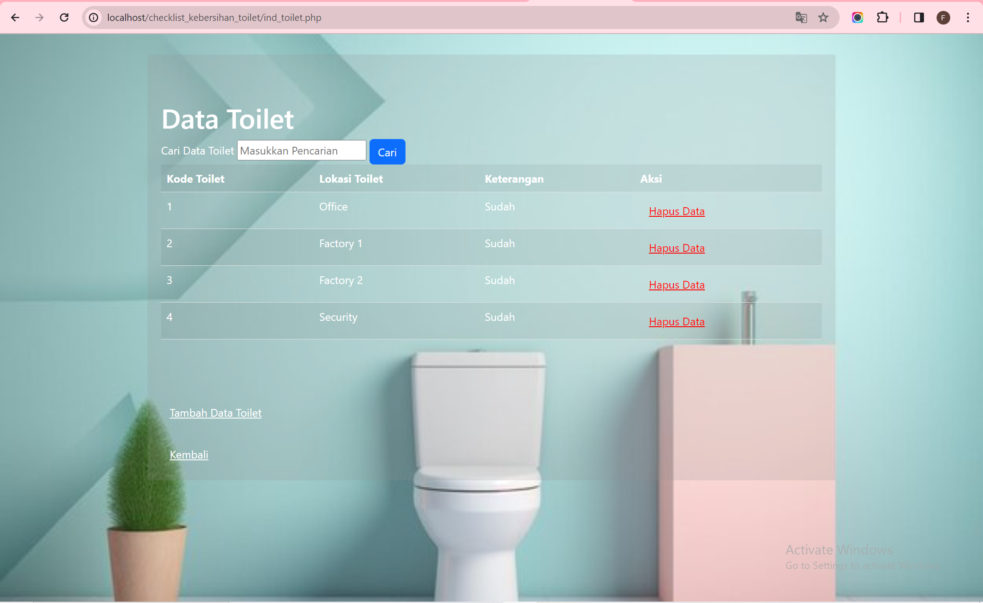

**## Mmembuat file tam_toilet.php**

```

<?php

error_reporting(E_ALL);

include_once 'koneksi.php';

if (isset($_POST['submit']))

{

    $toilet_id = $_POST['toilet_id'];

    $lokasi = $_POST['lokasi'];

    $keterangan = $_POST['keterangan'];

    $sql = 'INSERT INTO toilet (id, lokasi, keterangan) ';

    $sql .= "VALUE ('{$toilet_id}', '{$lokasi}', '{$keterangan}')";

    $result = mysqli_query($conn, $sql);

    header('location: ind_toilet.php');

}

?>

<!DOCTYPE html>

<html lang="en">

<head>

    <meta charset="UTF-8">

    <title>Febriyani Nurhida UAS</title>

    <link href="https://cdn.jsdelivr.net/npm/bootstrap@5.3.0-alpha1/dist/css/bootstrap.min.css" rel="stylesheet" integrity="sha384-GLhlTQ8iRABdZLl6O3oVMWSktQOp6b7In1Zl3/Jr59b6EGGoI1aFkw7cmDA6j6gD" crossorigin="anonymous">

</head>

<body style="margin-top: 30px; background-image: url('toilet.jpg'); background-size: cover;">

<div class="container" style="width: 50%; padding: 20px; background-color: rgba(0, 0, 255, 0.1);">

        <h1 style="color: #FFFFFF; text-align: center;">Tambah Data Toilet</h1>

        <div class="main">

            <form method="post" action="tam_toilet.php" enctype="multipart/form-data">

                <div class="input-group">

                    <span class="input-group-text">Kode Toilet</span>

                    <input class="form-control" type="text" name="toilet_id">

                </div>

                <div class="input">

                    <label style="color: #FFFFFF;">Lokasi</label>

                    <select class="form-select" aria-label="Default select example" name="lokasi">

                        <option value=""></option>

                        <option value="Office">Office</option>

                        <option value="Factory 1">Factory 1</option>

                        <option value="Factory 2">Factory 2</option>

                        <option value="Security">Security</option>

                    </select>

                </div>

                <div class="input">

                    <label style="color: #FFFFFF;">Keterangan</label>

                    <select class="form-select" aria-label="Default select example" name="keterangan">

                        <option value=""></option>

                        <option value="Sudah">Sudah</option>

                        <option value="Belum">Belum</option>

                    </select>

                </div> <br>

                <input class= "btn" style="background-color: #2C74B3; color: #FFFFFF;" type="submit" name="submit" value="Simpan">

            </form>

        </div>

    </div>

</body>

</html>

```

outputnya :

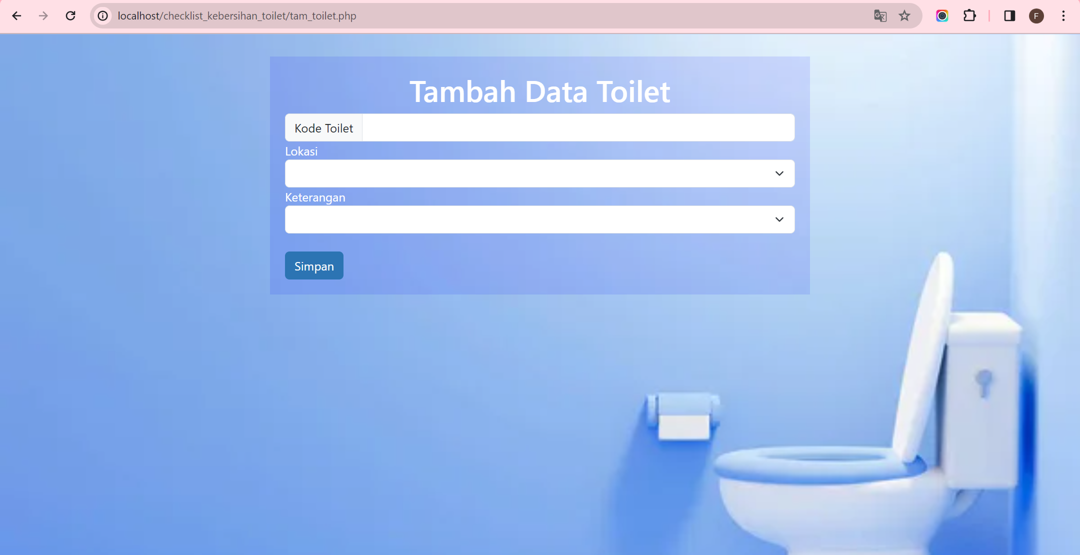

**Membuat file hap_toilet.php**

```

<?php

include_once 'koneksi.php';

$id = $_GET['id'];

$sql = "DELETE FROM toilet WHERE id = '{$id}'";

$result = mysqli_query($conn, $sql);

header('location: ind_toilet.php');

?>

```

